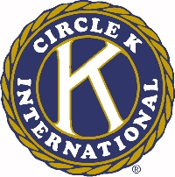
The 46th Annual Ohio District Circle K Convention

Trophy/Plaque/Certificate Checklist

This year each respective club will have the option to choose whether or not it would like to receive a trophy/plaque or a certificate if it wins an award. If your club chooses a certificate instead of a trophy/plaque, the money that would go toward that trophy will be donated to this year’s District Concern, the American Red Cross. The awards listed below that have the plaque option are given to an individual person, and the awards listed below that have the trophy option are given to the club: this is the only reason that some awards have plaque and some have trophy. Please fill out this form and send it in with the awards packet.

For each of the following awards, please circle whether your club would like to receive a trophy/plaque or a certificate.

- Lanton Lee Outstanding Club President Award Certificate Plaque
- Outstanding Club Vice President Award Certificate Plaque
- Linda M. Stiegler Outstanding Club Secretary Award Certificate Plaque
- Andrew Littlefield Outstanding Club Treasurer Award Certificate Plaque
- Ohio P.A.C.E.setter Award Certificate Plaque
- Brian Ritchie Outstanding Club Committee Chairperson Award Certificate Plaque
- Single Service Award Certificate Trophy
- Ken Creasy Award Certificate Trophy

